**Produce a plot with the relative proportion of children residing in Australia, Germany, Italy and India.**

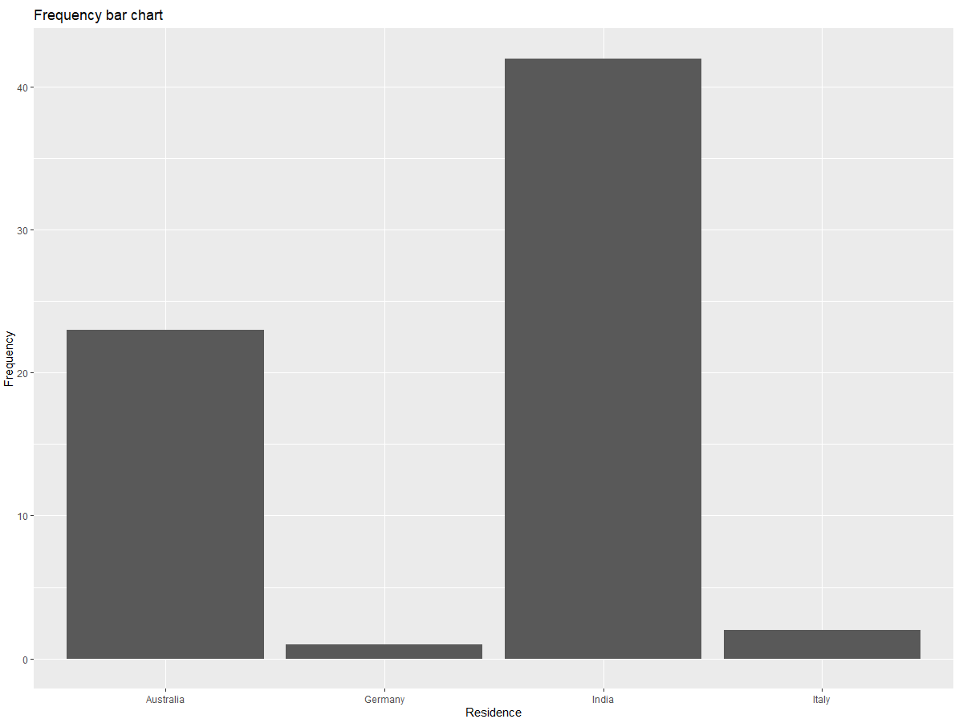

**Comment on your visualization and suggests one alternative to your plot, highlighting its advantages.**

I used filter from the plotly package to create a sub dataset consisting of only row whose residence are in one of the following countries: Australia, India, Italy and Germany.

Then the column residence was extracted in a table which was used to create a barplot using the ggplot2 package.

Based on the data from the child.csv dataset, Australia has a frequency of 23, Germany has a frequency of 1, Italy has a frequency of 2 and India has a frequency of 42 respectively.

The plot clearly shows India has the highest number of residence, followed by Australia, then Italy and then Germany. This visualization makes it easy to grasp the differences in frequency of the different countries.

An alternative plot that could have been used is a donut chart; a donut chart is essentially a hybrid of pie charts and bar graphs.

* Donut charts have a simple structure and are easy to draw.
* They are easily understood by even a non-professional.
* Donut charts are good for comparing comparative data.
* These charts require minimum additional explanation.
* Donut charts can be visually checked for the accuracy of its data distribution.